|  |  |  |  |
| --- | --- | --- | --- |
|  |  | |  |
|  | | **HIMADRI SPECIALITY CHEMICAL LIMITED** | | |  |  |
|  | |  | | |  |  |
| **Momentum Score** | | 0.93 | | |  |  |
|  | |  | | |  |  |
| **Technical Analysis** | |  | | |  |  |
| **Daily** | | UP | | |  |  |
| **Weekly** | | UP | | |  |  |
| **Monthly** | | UP | | |  |  |
|  | |  | | |  |  |
| **Fundamental Analysis** | | Strong Fundamentals | | |  |  |
|  | |  | | |  |  |
| **Recommendation** | | BUY | | |  |  |

**SMIF REPORT**

**HIMADRI SPECIALITY CHEMICAL LIMITED**

|  |  |
| --- | --- |
| BSE: | [500184](https://www.bseindia.com/stock-share-price/himadri-speciality-chemical-ltd/HSCL/500184/) |
| NSE: | HSCL |
| NIFTY 50: | 24,835 |
| SENSEX: | 81,332 |
| CMP: | ₹ 422 |
| RECOMMENDATION : | BUY |
| DATA: | JUL 26, 2024 |

|  |  |
| --- | --- |
| Market Cap | ₹ 20,857 Cr. |
| Enterprise Value | ₹ 20,731Cr. |
| Book Value | ₹ 61.8 |
| Face Value | ₹ 1 |
| Promoter holding | 50.2% |

|  |  |
| --- | --- |
| ROE | 15.7 % |
| ROCE | 19.1 % |
| ROA | 10.1% |
| Debt to equity | 0.2 |
| EPS | ₹ 9.58 |
| PE | 46.6 |

|  |  |
| --- | --- |
| **Momentum (90 days )** | **0.93** |
| **QoQ sales ( compare to last )** | **2.0%** |
| **QoQ profit (compare to last )** | **7.0%** |
| **YOY- Quarterly sales growth** | **26.24%** |
| **YOY- Quarterly profit growth** | **42.42%** |
| **3Years sales CAGR** | **36%** |
| **3Yrs profit CAGR** | **106 %** |
| **Cash flow from operating** | **March-23= 54 cr. March-24= 405 cr.** |
| **Net Cash Flow** | **March-23= 34 cr. March-24 = 7 cr.** |

**STOCK PERFORMANCE CHART**

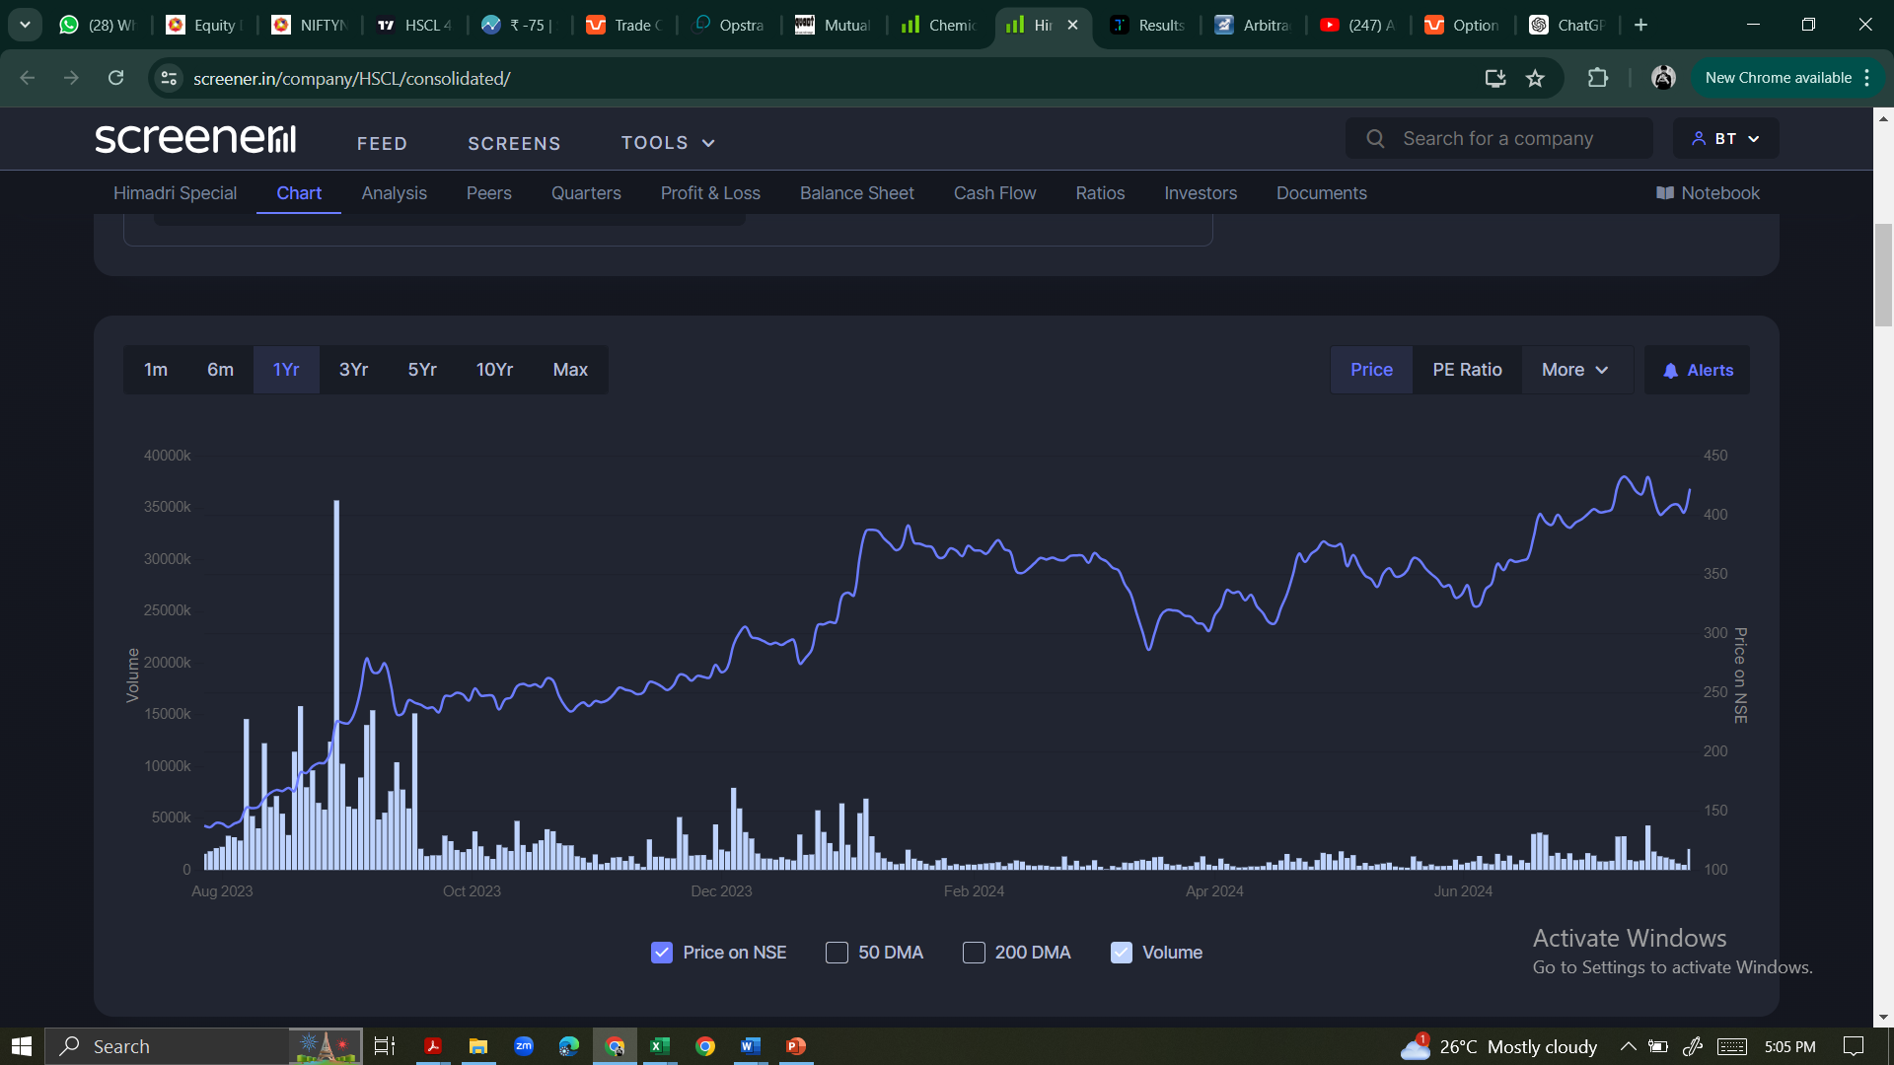

**Technical Analysis**

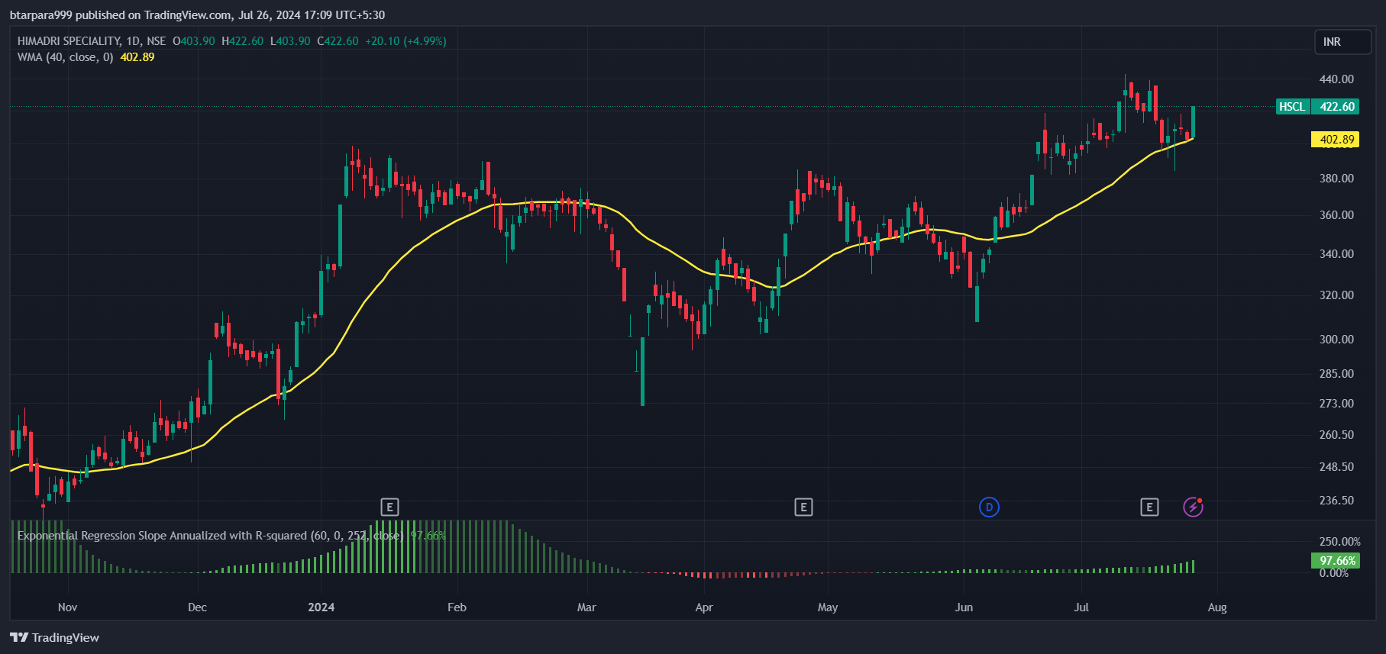 (**1) Daily**

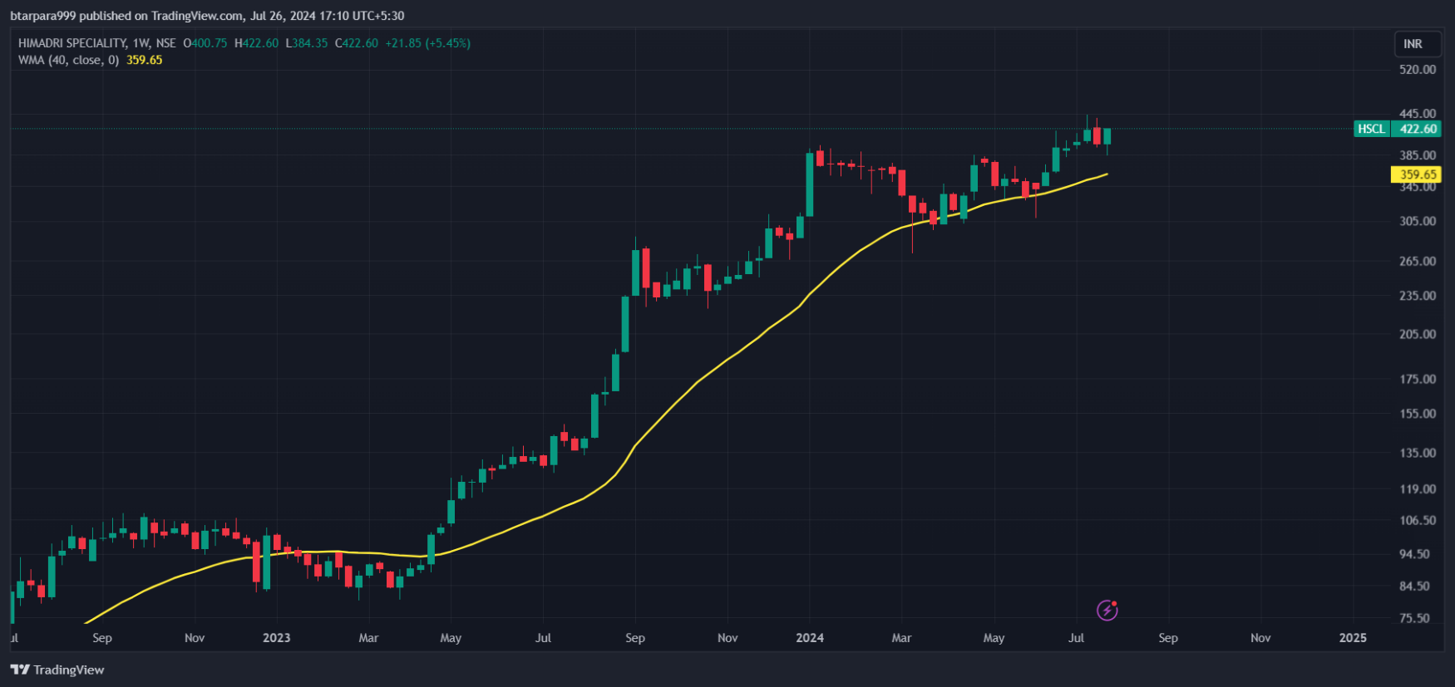**(2) weekly**

**Bhautik Tarpara**

**(3) Monthly**

